

## 

*At Wyalong Public School students, staff and the community are respectful, responsible and resilient learners.  We have high expectations of ourselves and others. We are life-long learners and responsible citizens.*

*Everyone is someone at Wyalong Public School!*

Week 4 17th May 2022

**Welcome to Week 4!**

**District Cross Country**

On Friday 20th May, students will be representing our school at the Lower Lachlan Cross Country Carnival at Tullibigeal. Students will need to pack warm clothes and spare shoes as the track could be very muddy. We wish all the students the very best.

**NAPLAN**

Congratulations to our Year 3 and 5 students for completing the NAPLAN. Thank you to all the students and the parents who ensured all students were here on those days.

**Past and Present**

This term in history, students are looking at the past and present and investigating why societies change.

Last week in 1/2, students were looking at how toys have changed over the years. They enjoyed playing marbles and knuckles. If anyone would like a challenge in knuckles, please see Mrs Blackwood!

If anyone has anything or stories from the ‘past’ that they would like to share with the school, please contact your child’s teacher.

**Doing it for Dolly Day**

Last Friday, students and staff participated in ‘Do It For Dolly Day’ which is a day dedicated to bringing the community together, spreading kindness and uniting in taking a stand against bullying.

To continue spreading the kindness now and in the future, we will be embracing ‘zero tolerance of put downs.’ We are encouraging everyone to think before they speak and if it is not kind or thoughtful then do not say it.

**Speech Pathologist**

This Wednesday, Tracey our speech pathologist, will be visiting the school. We are very fortunate to have her in our school every fortnight. This fortnight she will be working in the kindergarten classroom and focusing on oral language.

After school all staff will be participating in professional learning delivered by Tracey. This learning is valuable in our understanding of the best way to teach our students.

**Uniform Improvement**

Thank you to students and parents for making an effort in ensuring all students are in their full school uniform. Please remember if you have any donations for our school’s second-hand pool, please drop them off at the office.

**Save the Date - Parent Interviews**

This term our parent interviews will be held Tuesday 14th of June. We encourage all parents to meet and talk to your child’s teacher. You know your child the best and these opportunities allow us to all work together.

**New Playground**

This week the P&C will be ordering our school’s new playground equipment. The playground will arrive early next term. There will be a few weeks when there will be no playground equipment for the students. This will allow time for our contractors to prepare the site.

**Canteen**

**Tuesday 17th May 2022**

**5.30pm @ school library**

Canteen will now only be run on a Friday.

Have a wonderful week,

Kylie Taylor

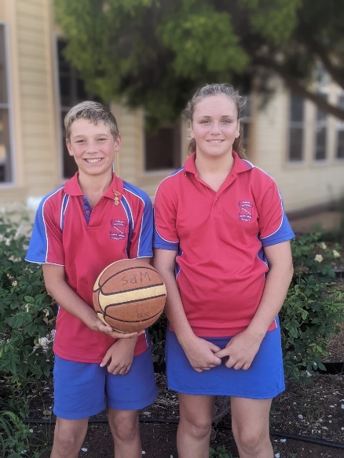Principal

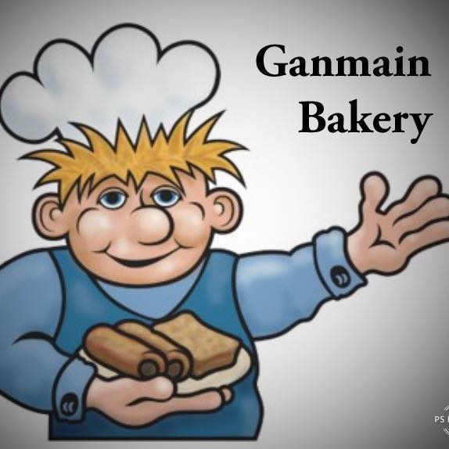

School Times

8.55am Morning Exercise

9.05am Class

10.30am Fruit Break

11.15am LUNCH

12.00 Class

1.30pm RECESS

2.00pm Class

3.00pm End of school

**P&C Meeting**

**Order form attached**

*Tuesday 17th May 2022*

**District Cross Country**

*Friday 20th May 2022*

**Simultaneous Story Time**

*Wednesday 25th May 2022*

**June Long Weekend Holiday**

Toppy fresh is a healthy snack available for students to purchase on **Wednesdays. Money must be returned to the school by Tuesdays.**

*Monday 13th June 2022*

**Parent Teacher Interviews**

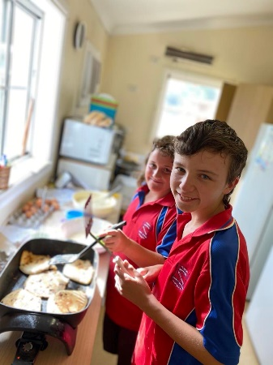*Tuesday 14th June 2022*

**Western Cross Country**

*Wednesday 15th June*

**Tuesday 17th May 2022**

**5.30pm @ school library**



There are a lot of new jumpers with **NO NAMES** on them in lost property.

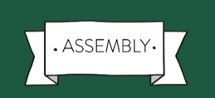

**Assembly Awards**

***Respectful, Responsible & Resilient learners***

*Liam Rowland* - for using neat letter formation when writing.

*Soren Duguid* - for giving interesting answers to questions during class discussions.

*Bella Bell* - for trying hard during sounds.

*Tessa Stergo* - for displaying responsibility in all areas of learning.

*Izaac Thomas* - for being a resilient learner during reading.

*Jonas Connor*  - for continuing to develop his Bounce Back strategies.

*Grace Clements*  - for always using manners towards everyone.

*Lachlan Beiser* - for ensuring he is always an active participant in classroom discussions.

*Kesaia Paewhenua* - for making a smooth transition to Toppy School.

*Alice Norris* - for always being respectful to others during class time.

*Hayley Wilton* - for consistent effort during writing.

*Tyler Jackson* - for attempting activities even when challenging.

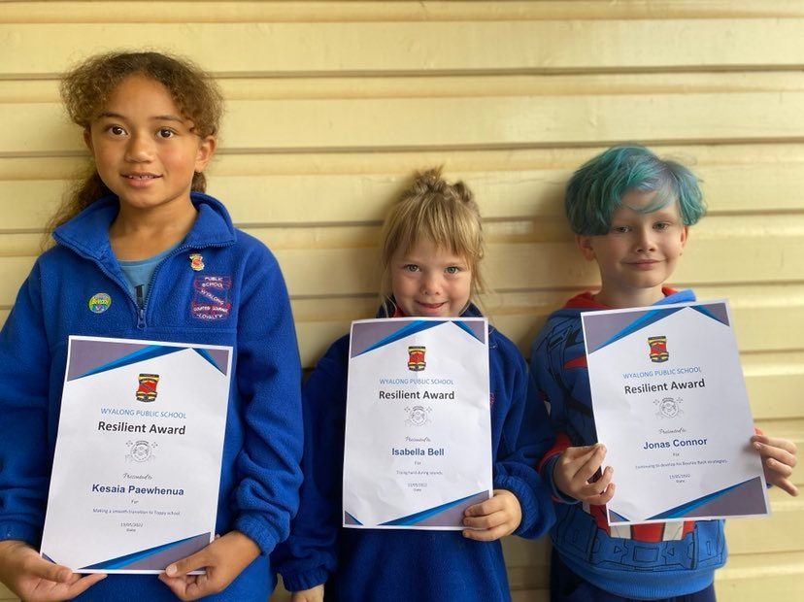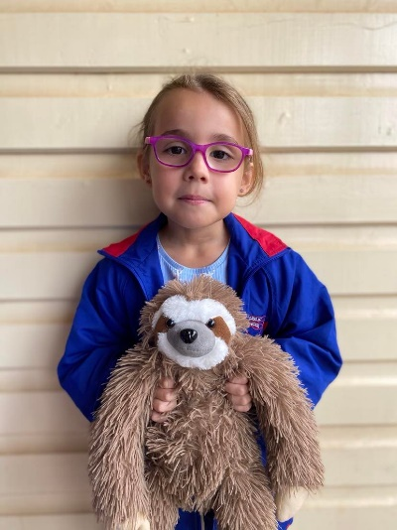



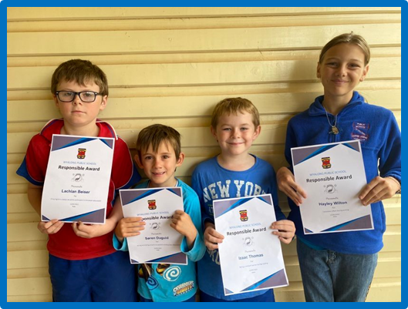

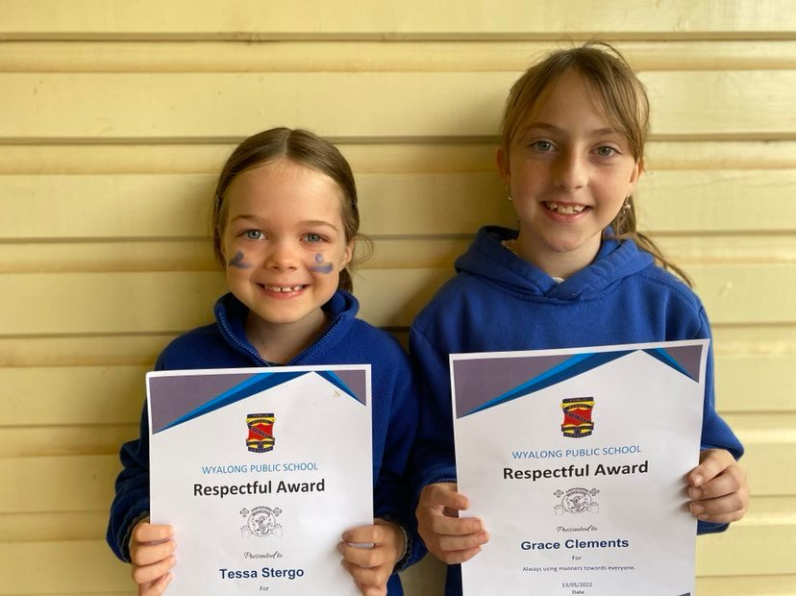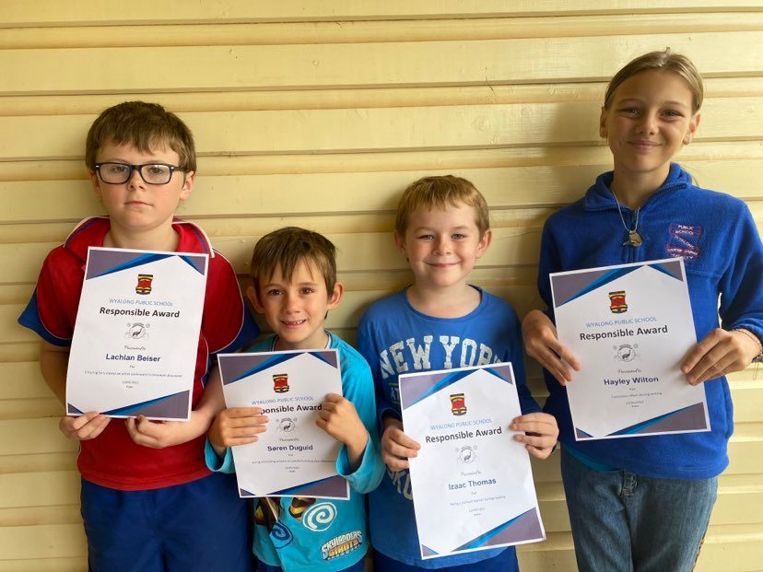

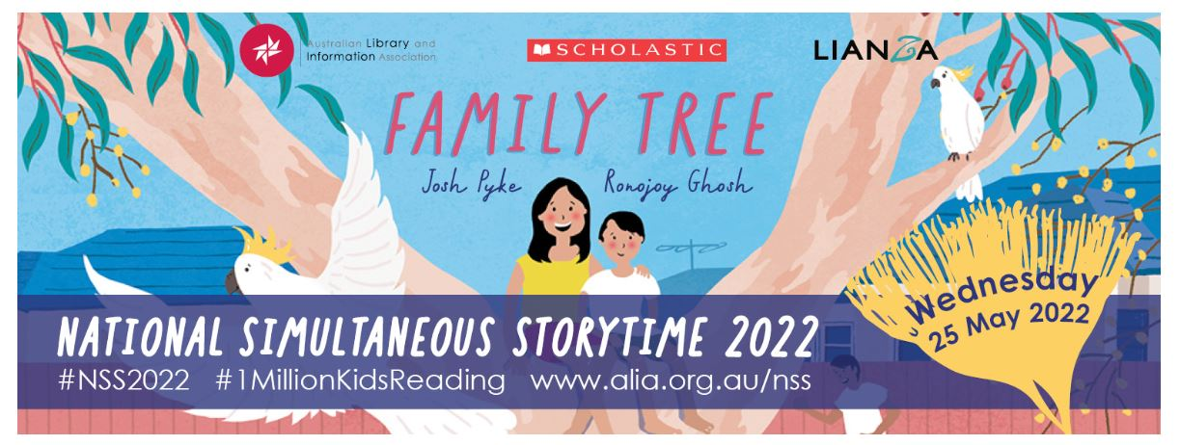

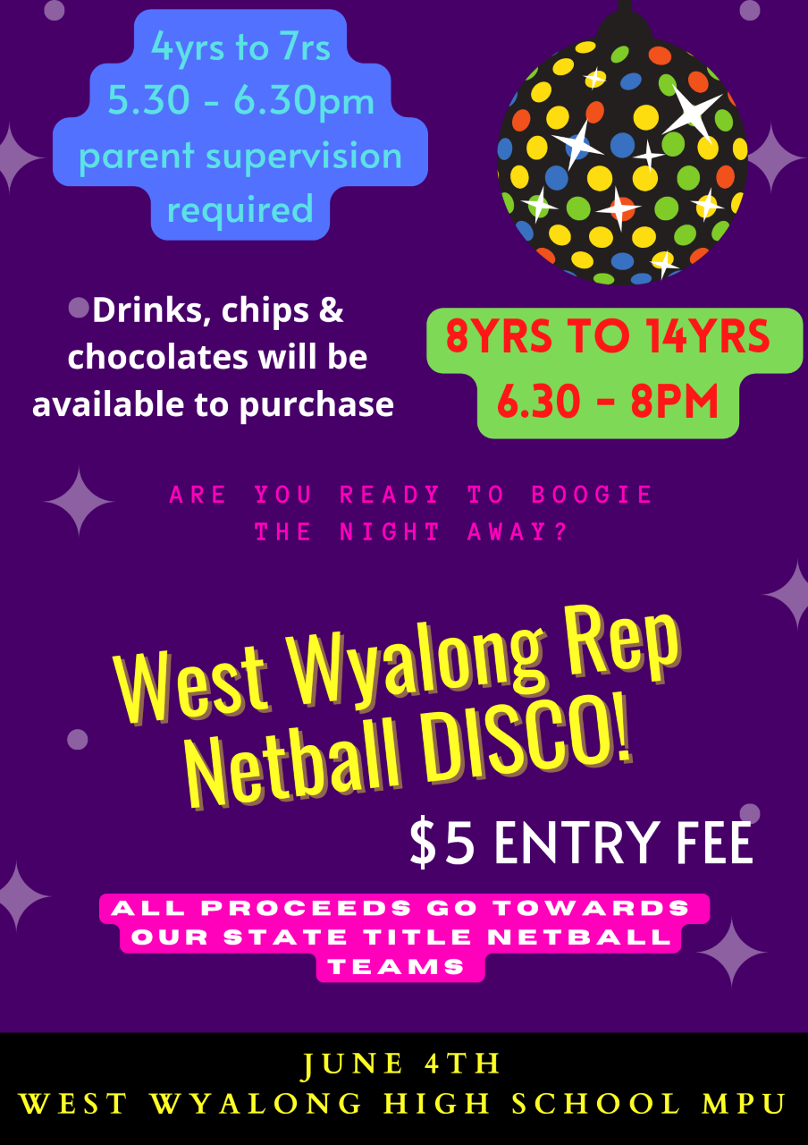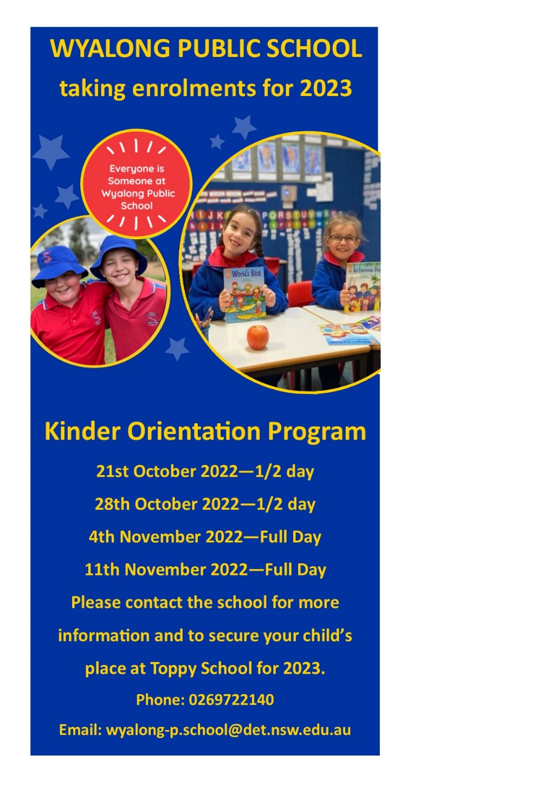

Wyalong Public School Term 2/3 2022

School Times

8.55am Morning Exercise

9.05am Class

10.30am Fruit Break

11.15am LUNCH

12.00 Class

1.30pm RECESS

2.00pm Class

3.00pm End of school

|  |  |  |  |  |  |
| --- | --- | --- | --- | --- | --- |
| **Week** | **Mon** | **Tue** | **Wed** | **Thu** | **Fri** |
| 4 | 16 | 17 P&C Meeting | 18 | 19 Middle School | 20 District Cross Country |
| 5 | 23 | 24 | 25 Simultaneous Story Time | 26 Middle School | 27 Assembly |
| 6 | 30 | 31 | 1 June | 2 Middle School | 3 |
| 7 | 6 | 7 | 8 | 9  Middle School | 10 Assembly |
| 8 | 13 June Long Weekend | 14 P&C Meeting Parent Teacher Interviews | 15 Western Cross Country | 16 Middle School | 17 |
| 9 | 20 | 21 | 22 | 23 Middle School | 24 Assembly |
| 10 | 27 | 28 | 29 | 30 Middle School | 1 July  Last Day of Term 2 |
| Term 3  1 | 18  SDD | 19 Students Return | 20 | 21 Middle School | 22 |
| 2 | 25 | 26 Athletics Carnival | 27 | 28 Middle School | 29 |

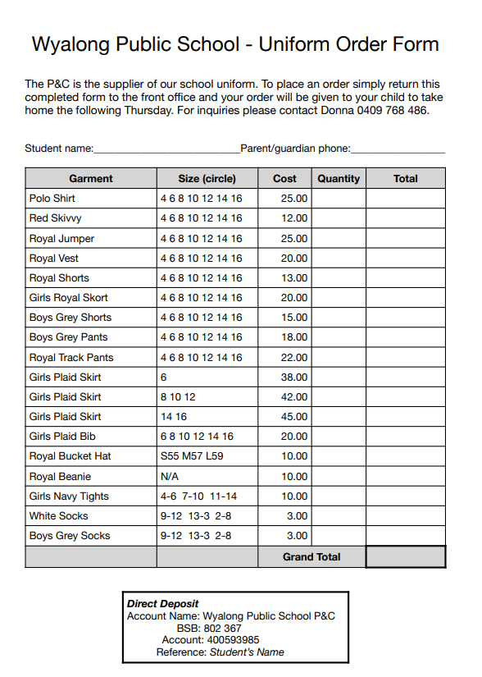

Please see following page for our NEW ordering of uniform online.

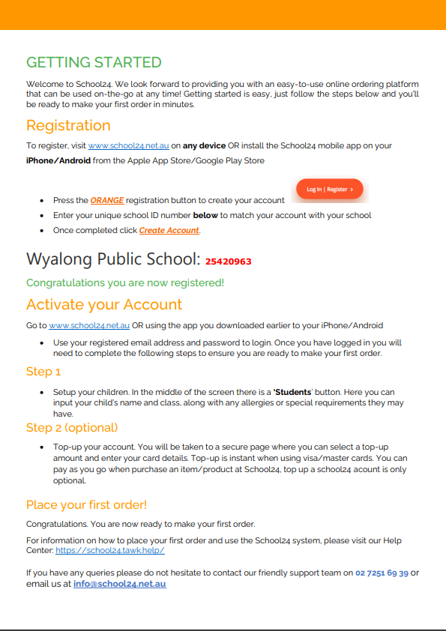

**Friday Only**

Canteen Menu Term 2 2022

**LUNCH**

Chicken Nuggets .50c ea

Tub Gravy .50c

Tomato Sauce .50c

BBQ Sauce .50c

Pizza ham & pineapple on English Muffin $2.50

Pizza cheese & bacon on English muffin $2.50

Toasty (ham/cheese/tomato) $4.00

Chicken Burger $4.00

Party Sausage Rolls $1.00 ea

Party Pies $1.00 ea

Chicken or Beef Noodles $2.00

**DRINKS**

Water $1.00

Fruit box/popper $1.00

Strawberry Flavoured Milk $1.00

Chocolate Flavoured Milk $1.00

Juice Bomb – lemon, apple blackcurrant & watermelon $2.00

**RECESS**

Moosies (chocolate or bubblegum) $2.00

Cheese and Crackers $1.00

Honey Soy Chips $1.00

Jumpy’s $1.00

Juicies $1.50

Zooper Dooper .50

Ka-Bluey – Blue raspberry or Sour $1.00

